Lesson Plan
Grade Level: Kindergarten
Topic: Community Helpers

Anticipatory Set:
- I will start out by showing an image of a fire rescue team putting out a fire.
- I will ask all of the students, “What do you see in this picture?”
Rationale:
My rationale behind this activity is to have the children notice that the community helper that comes to the rescue when there is a fire, is a fire fighter. Also to have them point out that you can notice a community helper by the type of clothes or uniforms they wear. Then I want to discuss deeper why fireman wear this type of uniform in particular compared to what other community helpers wear.
Example-
- Why are fire fighter’s uniforms so heavy?
- Why do fire fighters wear an oxygen mask?
- Why do fire fighters wear thick boots?
- What would happen if fire fighters did not have on heavy clothes while entering a fire?

Multiple Intelligences: Visual- Spatial
Bloom’s: Knowledge and Comprehension
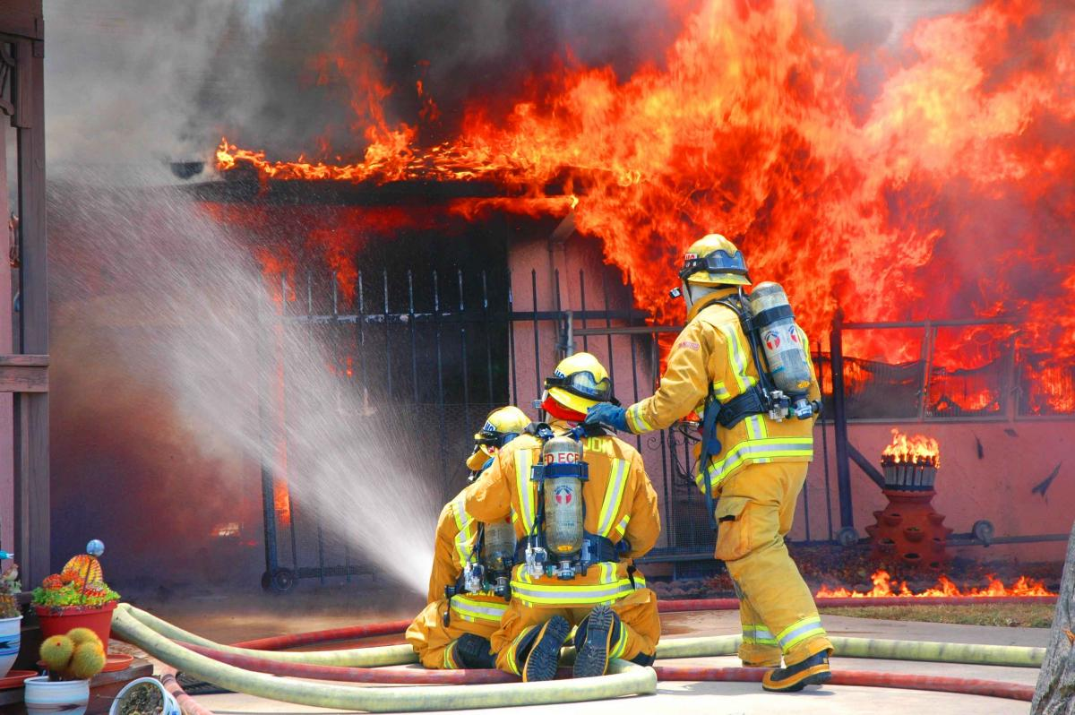

http://eastcountymagazine.org/node/3889

Learning Outcomes:
- I want my students to be able to identify community helpers in their community by their specific uniforms and be able to identify what they do.
- I want my students to strengthen their identification skills.

Activating Prior Knowledge:
- I will have them sit on their squares on the rug where they will all have a clear view of the class easel.
- Here I will ask them what they know about community helpers so far, while we make a class web of all the information we have learned.
- I will ask them questions like, “What do community helpers do? Who are community helpers? Where do community helpers work?”
- In previous assignments I have instructed them what community helper goes to which place of work.
Community
Helpers

*This is the type of graphic organizer (Web) that I will create with them on the large easel paper to help them organize their thoughts of how much they already know.
Multiple Intelligences: Verbal-Linguistic and Visual-Spatial
Bloom’s: Knowledge

Content Presentation:
- Through a simulation of the children trying on different types of uniforms while I explain to them why each community helper has each particular uniform they will understand more clearly how to match each helper with their uniform.
  - I will bring in dress up uniforms so that they can really get a feel and better understanding of what they look like.
  - I will call probably three to five students to be my helpers. They will be the ones who put on the uniform while the rest of the students sit in a circle helping to analyze the uniforms in a class discussion.
- I will explain that police officers must carry badges to prove to people in danger that they are “the good guys,” I will explain why fire fighter’s clothes are so heavy and protective, I will introduce why people like mail carriers have much lighter and more comfortable attire, etc. This will help them associate the helper to the job, and to also help them find a community helper if they were in need of one.
Multiple Intelligences: Bodily- Kinesthetic and Visual-Spatial
Bloom’s: Application

Informal Assessment:
- With a work sheet that points out the main visual uniform pieces (example a firefighter’s hat to a fire fighter or a badge to a police officer) they will draw a line to the community helper that it matches.
- They will do this individually at tables so that I can circulate, checking each student’s work for understanding.
Multiple Intelligences: Verbal Linguistic and Visual- Spatial
Bloom’s: Comprehension

Formal Assessment:
(This formal assessment is meant to be done at the end of a unit on community helpers, not necessarily on just this lesson plan.)
- I will call them up individually to tell me five community helpers and what it is those people do to serve the community. Then they will need to tell me one characteristic of each type of uniform that each helper wears, that makes them identifiable compared to a regular person. The reason this is a verbal test is because they are an early kindergarten class and they have not learned to write yet, so verbal testing is the only way to know if they have retained the lesson.
- The other students could be working on the community helper informal assessment if these are both used for the same lesson.
Multiple Intelligences: Verbal Linguistic
Bloom’s: Comprehension and Knowledge

Self Reflection:
- I will go around to each individual table having the students hold up a red, yellow, or green card that displays how hard they feel they have worked today, while I ask them two to three questions.
- Do you believe you have learned more about community helpers?
- Do you understand why certain helpers wear particular uniforms?
- What do you remember the most about community helpers?

Common Core:
- 3. With prompting and support, describe the connection between two individuals, events, ideas, or pieces of information in a text.
- 10. Actively engage in group reading activities with purpose and understanding.

Lesson Plan Questions:
- Why do community helpers wear uniforms?
- What kinds of uniforms do community helpers wear?

Essential Questions:
- How do community helpers help to serve other people?
- Do you think our community could function without community helpers?

