Visual Discovery Activities

- Put up a picture of a house on fire. Ask the students what they see, ask them what type of community helpers they think they would see coming to help put out the fire? Also if there was people inside the house what other type of helpers might come?
  - Bloom’s: Knowledge
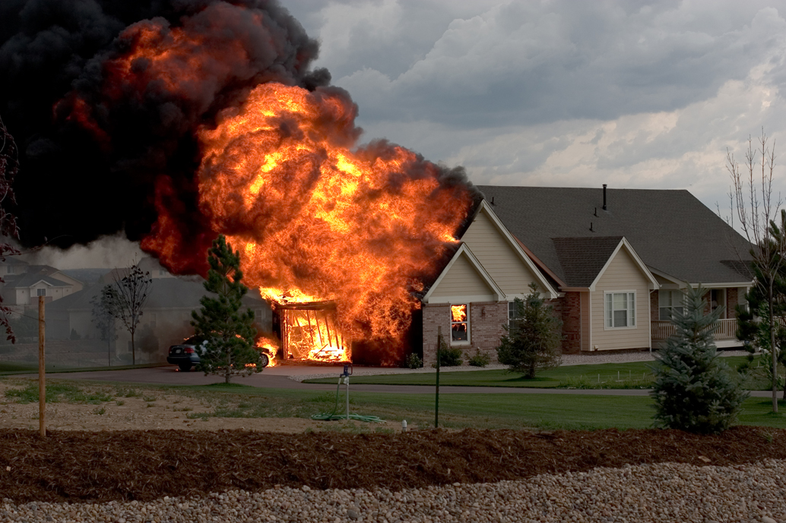
- Show a picture of community helpers. Have the class try to identify who these community helpers are. Then read them a story about jobs in the community that we have community helpers for. If you have time go back to the picture and see if they can now identify the community helper picture correctly. Or ask them what they have learned about community helpers from the story.
  - Bloom’s: Comprehension
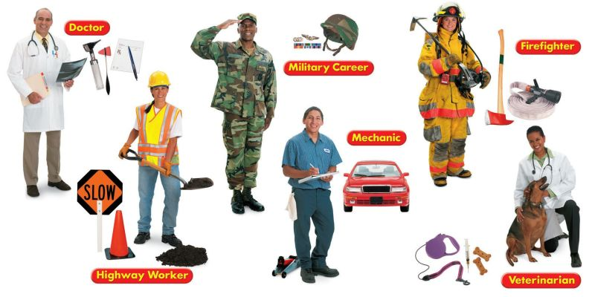
- Have your students take on the roles of different members in the community and act like that person would act. I would give them a scenario and they would have to figure out how to go about it if they were a doctor, a police officer, a principle, or a janitor. (Example, tell them a bank has just been robbed what would a police officer do?)

Core: Reading Standards for Informational Text-K

- With prompting and support, ask and answer questions about key details in a text.
7.) With prompting and support, describe the relationship between illustrations and the text in which they appear.
10.) Actively engage in-group reading activities with purpose and understanding.

